FPING, TRACEROUTE & MTR – COMPREHENSIVE TECHNICAL DOCUMENTATION
Network Reachability & Path Analysis Tools for Ethical Hacking & Penetration Testing
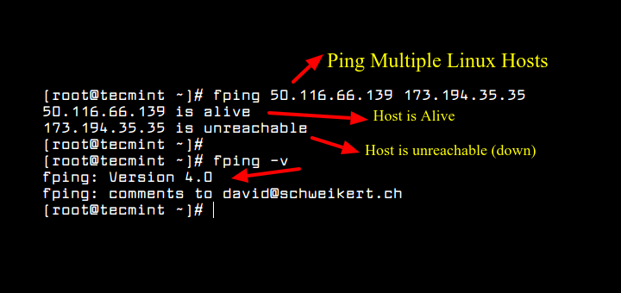
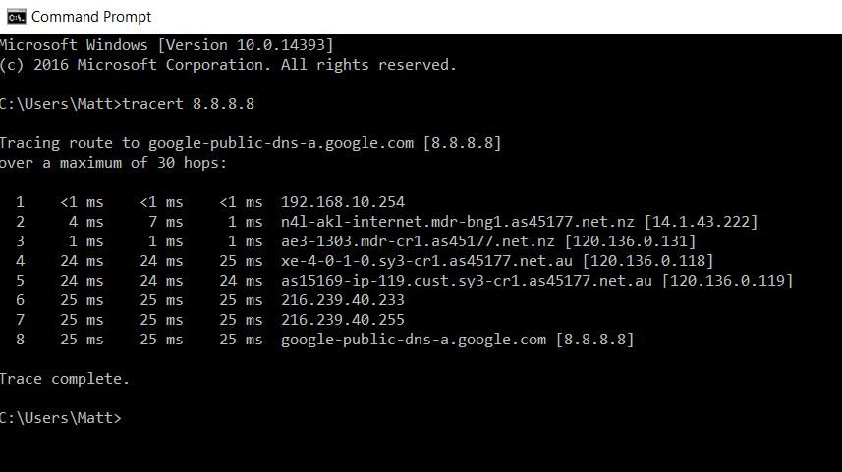
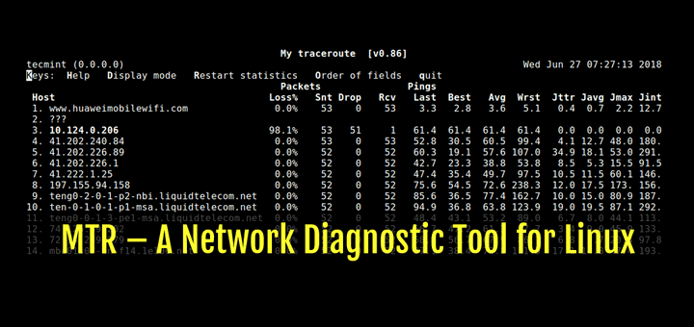
4

ABSTRACT
Network-level reconnaissance is a crucial component of penetration testing and cyber security assessments. Before identifying open ports or exploiting vulnerabilities, testers must understand which hosts are reachable and how network traffic flows between systems. This document presents a comprehensive technical study of FPING, TRACEROUTE, and MTR, three widely used network diagnostic and reconnaissance tools. The report explains their theoretical background, internal working mechanisms, command usage, practical case studies, advantages, limitations, and defensive considerations. The objective of this documentation is to provide an academic and practical understanding suitable for cybersecurity coursework, lab records, and professional penetration testing engagements.

PART A: FPING TOOL

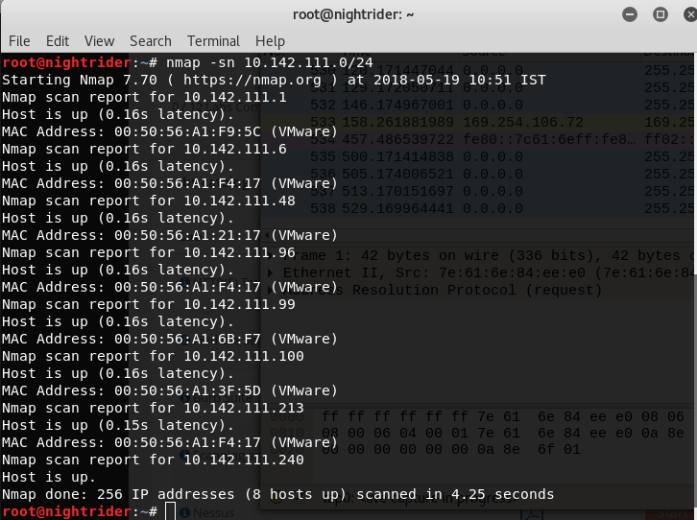
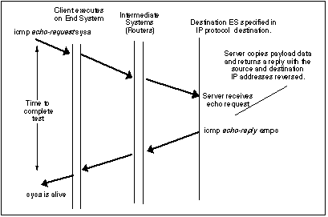

1. INTRODUCTION TO FPING
FPING is an advanced network utility designed to test the reachability of hosts on a network. Unlike the traditional ping command, which sends ICMP requests sequentially to one host at a time, FPING is capable of sending ICMP echo requests to multiple hosts simultaneously.
In penetration testing, FPING is commonly used for fast host discovery, especially when scanning large IP ranges. Its speed and scripting-friendly nature make it ideal for automation and large-scale reconnaissance.

2. OBJECTIVE OF USING FPING
The primary objectives of FPING are:
- To identify live hosts quickly
- To perform large-scale ICMP-based host discovery
- To reduce time spent during reconnaissance
- To generate clean input for further scanning tools like Nmap
FPING is typically used in the Information Gathering (Scanning) phase.

3. WORKING MECHANISM OF FPING
FPING sends ICMP Echo Request packets to multiple IP addresses in parallel. It listens for ICMP Echo Reply responses and records which hosts are reachable. By default, FPING focuses on efficiency and speed rather than detailed output.
Because FPING operates at the ICMP layer, it is effective when firewalls allow echo requests, but less effective in highly restricted environments.

4. COMMAND USAGE AND ANALYSIS (FPING)
4.1 Ping a Single Host
fping google.com
Checks whether the host is reachable.

4.2 Ping Multiple Hosts
fping google.com yahoo.com bing.com
Sends ICMP requests to multiple hosts simultaneously.

4.3 Scan an IP Range
fping -g 192.168.1.0/24
Identifies live hosts within a subnet.

4.4 Show Only Alive Hosts
fping -a -g 192.168.1.0/24
Displays only reachable hosts, suppressing unreachable results.

4.5 Quiet Mode
fping -q -g 192.168.1.0/24
Useful for scripting and automated scanning.

5. PRACTICAL CASE STUDY (FPING)
Scenario
A penetration tester needs to quickly identify active systems in a network before performing port scans.
Execution
fping -a -g 192.168.146.0/24
Observations
- Multiple active hosts were identified
- Inactive IPs were ignored
- Scan completed significantly faster than traditional ping
Impact
FPING reduced reconnaissance time and provided a clean target list for further testing.

6. ADVANTAGES & LIMITATIONS (FPING)
Advantages
- Extremely fast
- Supports large IP ranges
- Script-friendly
Limitations
- ICMP may be blocked
- Limited information beyond reachability

PART B: TRACEROUTE TOOL
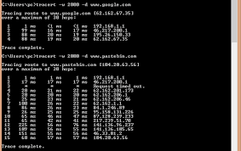
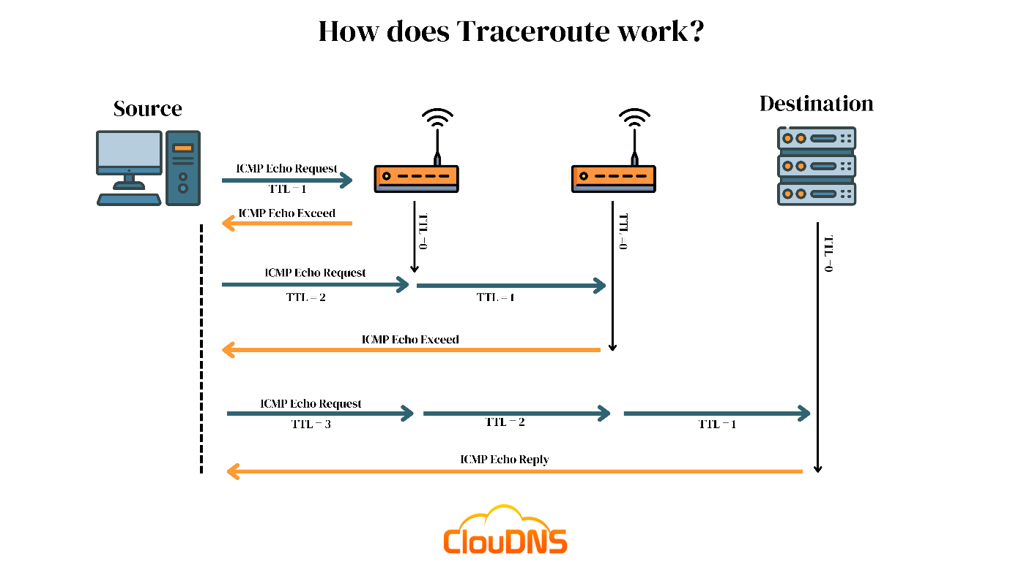
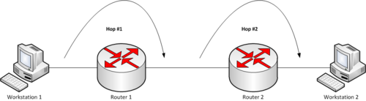

7. INTRODUCTION TO TRACEROUTE
Traceroute is a network diagnostic tool used to determine the path taken by packets from a source system to a destination. It reveals intermediate routers (hops) and the time taken to reach each hop.
In penetration testing, traceroute helps identify:
- Network topology
- Firewalls and filtering devices
- Geographical routing patterns

8. WORKING MECHANISM OF TRACEROUTE
Traceroute works by sending packets with increasing Time-To-Live (TTL) values. Each router decrements the TTL, and when it reaches zero, the router sends an ICMP “Time Exceeded” message back to the sender.
By incrementing TTL values, traceroute maps the entire path to the destination.

9. COMMAND USAGE AND ANALYSIS (TRACEROUTE)
9.1 Basic Traceroute
traceroute example.com

9.2 Use ICMP Instead of UDP
traceroute -I example.com

9.3 Limit Maximum Hops
traceroute -m 15 example.com

9.4 Numeric Output
traceroute -n example.com
Prevents DNS resolution for faster output.

10. PRACTICAL CASE STUDY (TRACEROUTE)
Findings
- Identified ISP routing structure
- Detected firewall hop delays
- Observed packet filtering at certain hops
Impact
Traceroute provided insight into network segmentation and routing defenses.

11. ADVANTAGES & LIMITATIONS (TRACEROUTE)
Advantages
- Reveals network path
- Useful for topology mapping
Limitations
- Some routers block ICMP/UDP
- Results may be incomplete

PART C: MTR TOOL
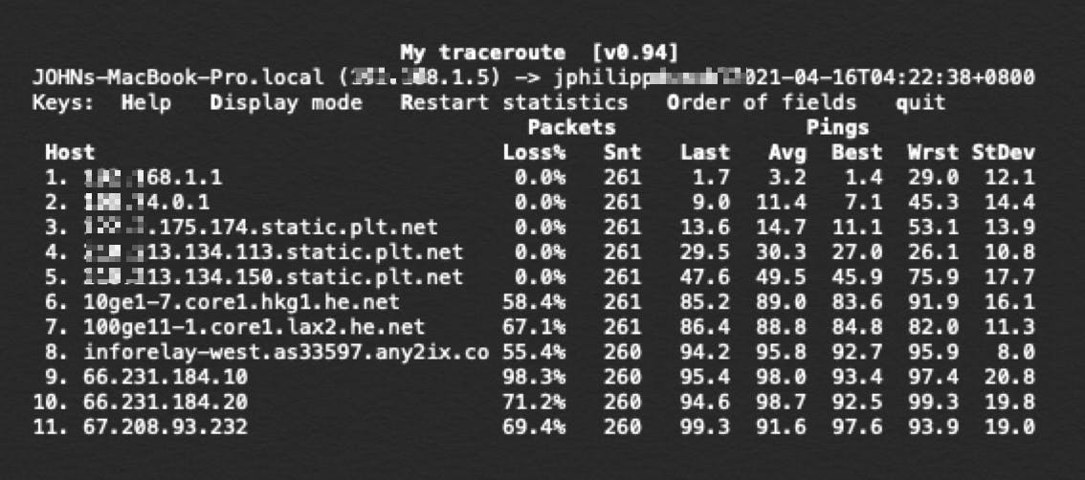
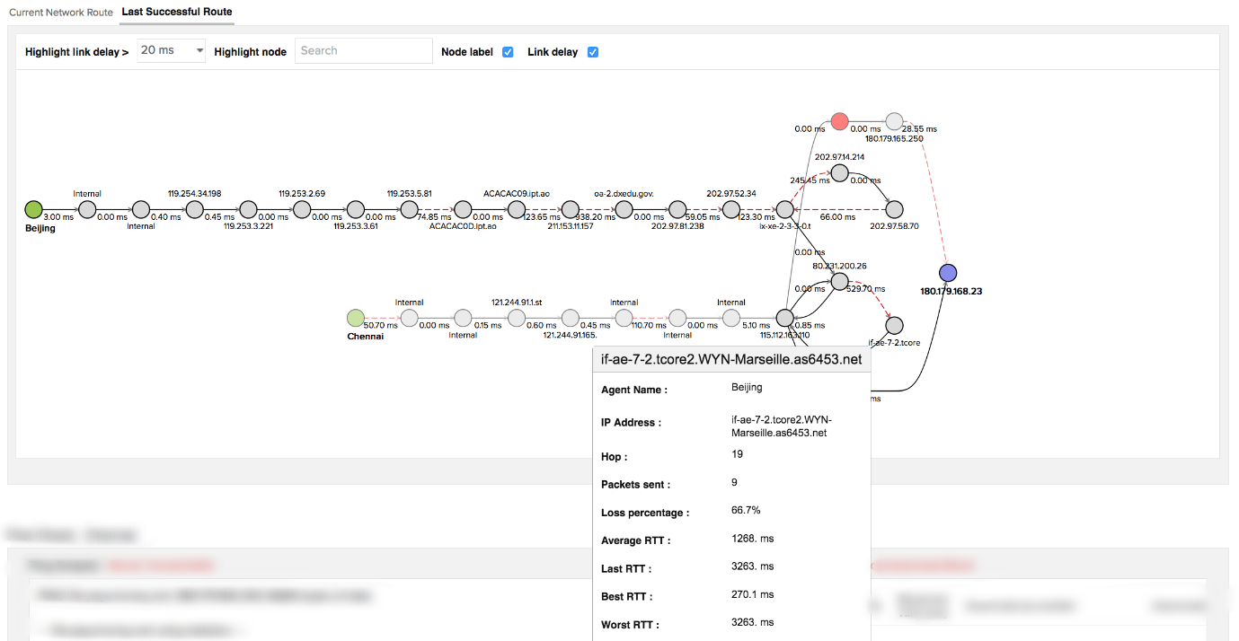
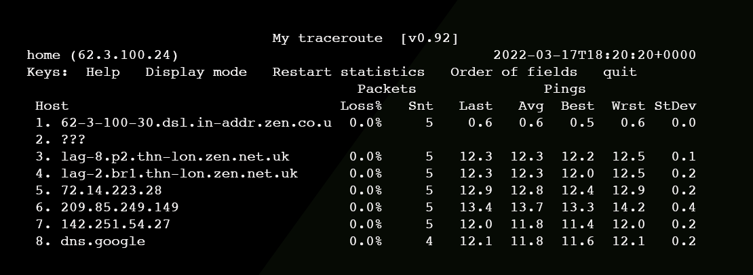

12. INTRODUCTION TO MTR
MTR (My Traceroute) is a powerful network diagnostic tool that combines the functionality of Ping and Traceroute into a single real-time interface. It continuously monitors the network path and displays packet loss and latency statistics for each hop.
MTR is widely used for advanced troubleshooting and performance analysis.

13. WORKING MECHANISM OF MTR
MTR repeatedly sends packets to the destination and records responses from each hop. Unlike traceroute, which provides a snapshot, MTR provides continuous statistics, making it ideal for identifying intermittent issues.

14. COMMAND USAGE AND ANALYSIS (MTR)
14.1 Run MTR in Interactive Mode
mtr example.com

14.2 Report Mode
mtr -r example.com
Generates a summarized report.

14.3 Limit Number of Cycles
mtr -c 10 example.com

14.4 Numeric Output
mtr -n example.com

15. PRACTICAL CASE STUDY (MTR)
Findings
- Identified packet loss at intermediate hops
- Measured latency variations
- Detected unstable routing paths
Impact
MTR provided deep insight into network performance and reliability.

16. COMPARISON: FPING vs TRACEROUTE vs MTR
Tool | Primary Purpose | Best Use Case
FPING | Fast reachability testing | Large-scale host discovery
Traceroute | Path discovery | Topology mapping
MTR | Continuous path analysis | Performance troubleshooting

17. SECURITY & DEFENSIVE CONSIDERATIONS
Organizations should:
- Monitor ICMP traffic
- Restrict unnecessary network diagnostics
- Use firewalls and rate limiting
- Detect reconnaissance behavior

18. LEGAL & ETHICAL CONSIDERATIONS
These tools must be used only on authorized systems and networks. Misuse may violate organizational policies and cyber laws.

19. CONCLUSION
FPING, Traceroute, and MTR are essential tools for understanding network reachability, routing paths, and performance. While simple in concept, they provide critical intelligence that shapes effective penetration testing strategies. Mastery of these tools is fundamental for any cybersecurity student or professional.

